Sam,

The circular regression doesn’t seem to be working particularly well on my computer, see screenshots (quite a challenge to take these by the way).
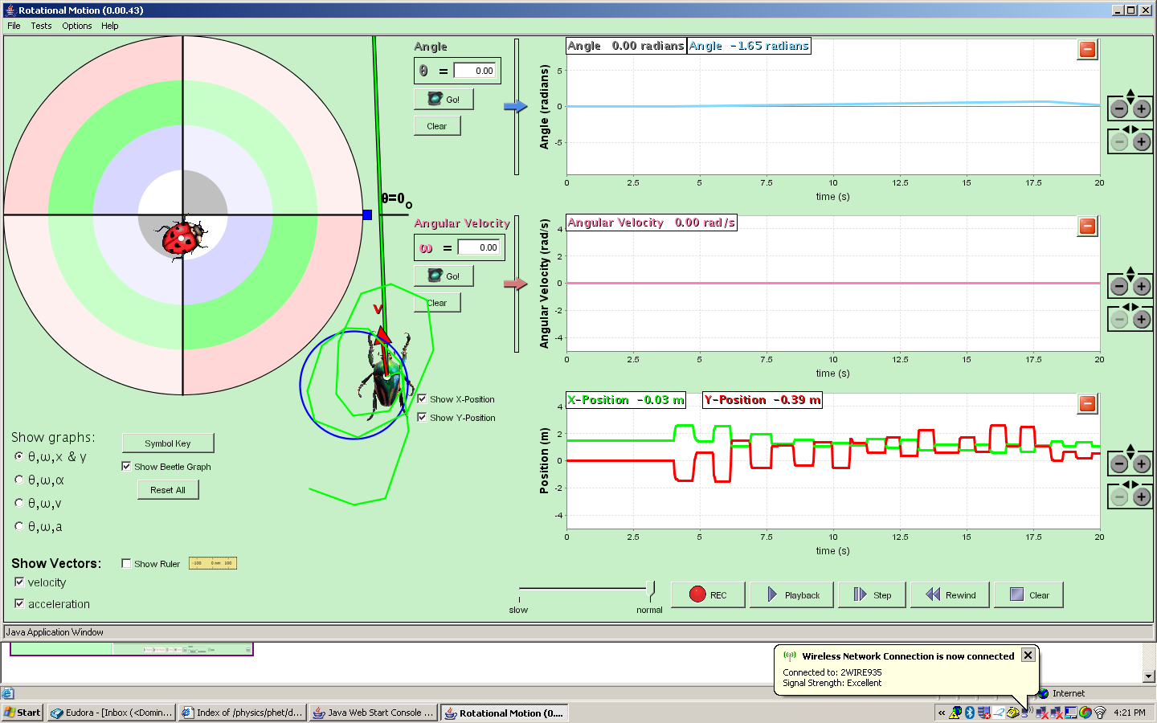

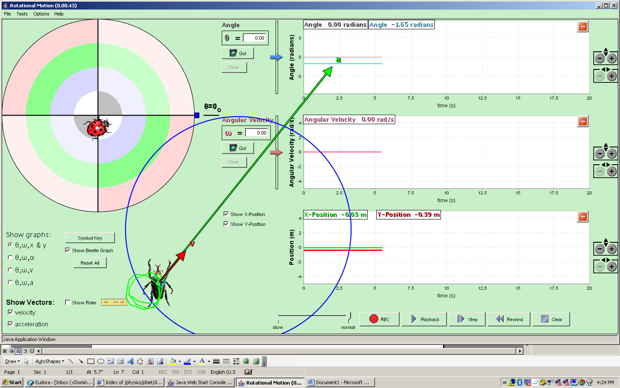

As for control/display issue, what do you think of this?
My goals here:
- Make color of control = color for platform data
- Make clearer which graph associated with which object
- Don’t use same colors for x and y as for v and a

I realize that you won’t be able to see the platform on angular velocity, but I think that is fine because all readouts will be same, emphasizing the point.

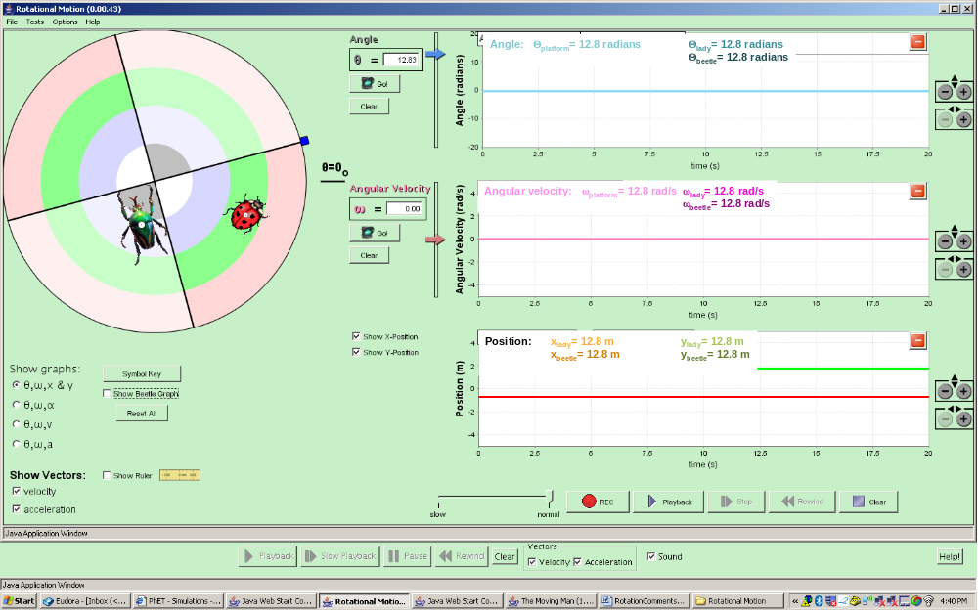
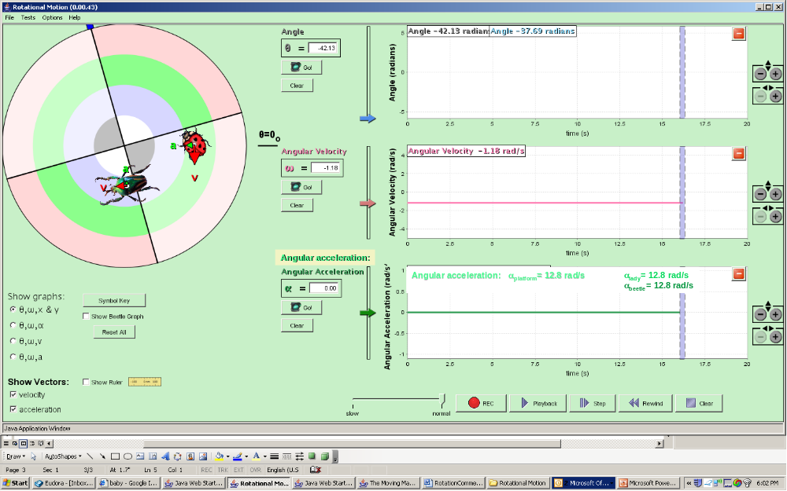
Right now, when “paused or stopped” and you play with wheel by hand or by moving the slider on the right of graph, the values for the wheel update, but not the bugs. However, values for bugs update in position. I think it would be good for values of angle to update so you know where the bugs are in theta as well as position.
If time is “Stopped”, can you update theta for bugs if they are being moved by hand. I find myself wanting to look at this if I want to set an initial theta for the bugs.

Can you still maintain “Go” and “Stop” on the controls even when the graph time has elapsed? This would be the same as maintaining “pause” and “rec” on the bottom (just that won’t actually record because it has run out of recording time. I think this is OK).

If time is in “Go”, I think we will want (in the end) to estimate angular velocity and acceleration for the bugs if they are being moved by hand. It seems like it would be easy to do this for theta right now… can you add this?

Right now, if you let it go beyond end of graph and keep going, then press clear, the graph starts recording, but the button keeps reading “Go” instead of “Stop”
Sometimes “record button doesn’t appear when it seems like it should”.

